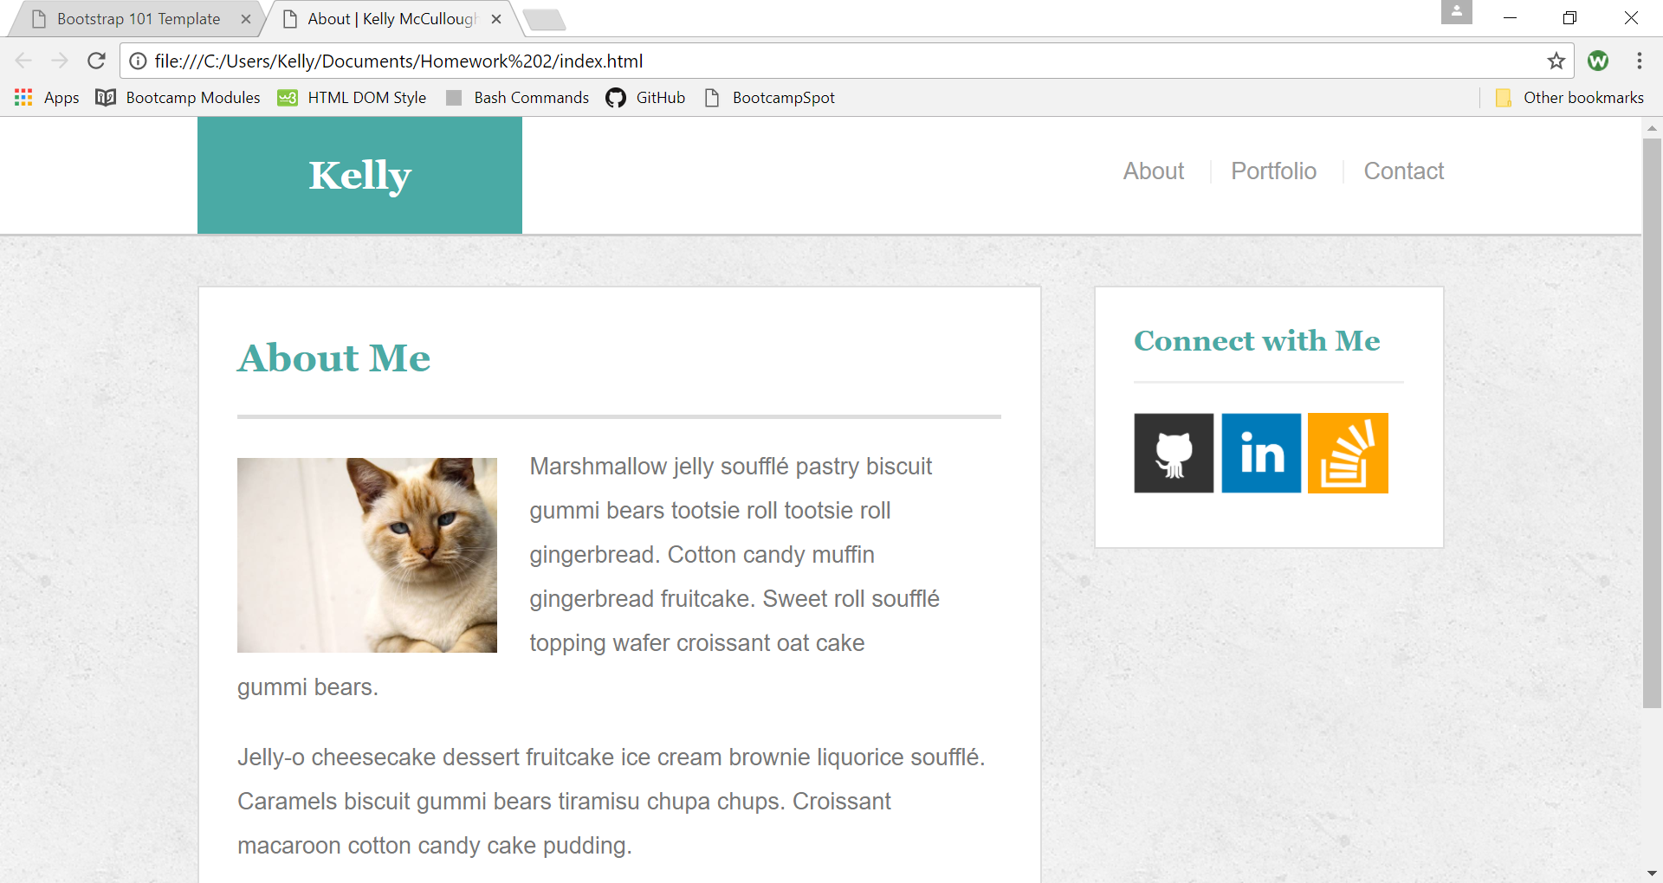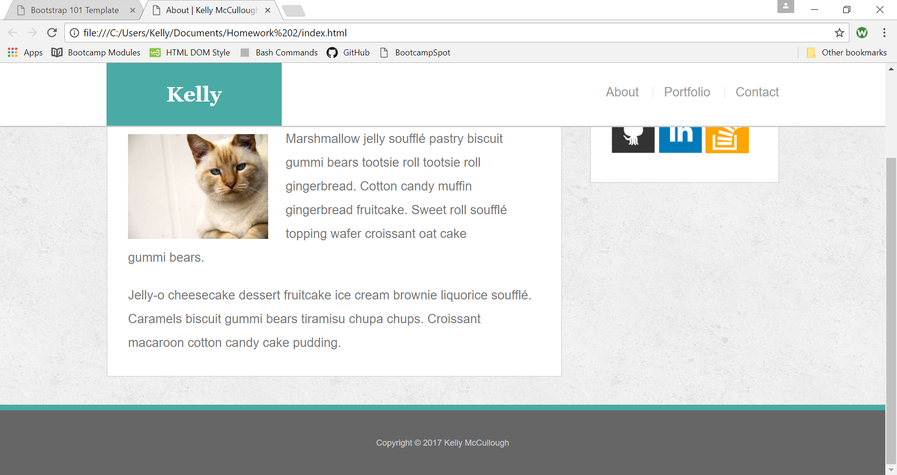

<!doctype html>

<html lang="en-us">

<head>

<meta charset="UTF-8">

<title>About | Kelly McCullough</title>

<link rel="stylesheet" type="text/css" href="reset.css">

<link rel="stylesheet" type="text/css" href="style.css">

<meta name="viewport" content="width=device-width, initial-scale=1">

</head>

<body>

<header id="masthead">

<div class="container">

<a href="index.html" id="logo">Kelly</a>

<nav>

<a href="index.html">About</a>

<a href="portfolio.html">Portfolio</a>

<a href="contact.html">Contact</a>

</nav>

</div>

</header>

<div id="main-container" class="container">

<section class="main-section">

<h1>About Me</h1>

<img src="cat.jpg" class="auth-image" alt="Your Name">

<p>Marshmallow jelly souffl&eacute; pastry biscuit gummi bears tootsie roll tootsie roll gingerbread. Cotton candy muffin gingerbread fruitcake. Sweet roll souffl&eacute; topping wafer croissant oat cake gummi&nbsp;bears.</p>

<p>Jelly-o cheesecake dessert fruitcake ice cream brownie liquorice souffl&eacute;. Caramels biscuit gummi bears tiramisu chupa chups. Croissant macaroon cotton candy cake pudding.</p>

</section>

<section class="sidebar">

<div id="connect">

<h2>Connect with Me</h2>

<a href="#"><img src="github-128.png" class="social" alt="GitHub" /></a>

<a href="#"><img src="linkedin-128.png" class="social" alt="LinkedIn" /></a>

<a href="#"><img src="stackoverflow-128.png" class="social" alt="Stack Overflow" /></a>

</div>

</section>

</div>

<footer>

<div class="container">

Copyright &copy; 2017 Kelly McCullough

</div>

</footer>

</body>

</html>